Tableau Interview Questions and Answers

1. What Are the Data Types Supported in Tableau?

Following data types are supported in Tableau:

* Text (string) values
* Date values
* Date and time values
* Numerical values
* Boolean values (relational only)
* Geographical values (used with maps)

2. How Will You Understand Dimensions and Measures?

|  |  |
| --- | --- |
| Dimensions | Measures |
| * Dimensions contain qualitative values (such as names, dates, or geographical data) * You can use dimensions to categorize, segment, and reveal the details in your data. * Example: Category, City, Country, Customer ID, Customer Name, Order Date, Order ID | * Measures contain numeric, quantitative values that you can measure (such as Sales, Profit) * Measures can be aggregated * Example: Profit, Quantity, Rank, Sales, Sales per Customer, Total Orders |

3. What is Meant by ‘discrete’ and ‘continuous’ in Tableau?

Tableau represents data depending on whether the field is discrete (blue) or continuous (green).

* Discrete - "individually separate and distinct."
* Continuous - "forming an unbroken whole without interruption."

The values are as shown:

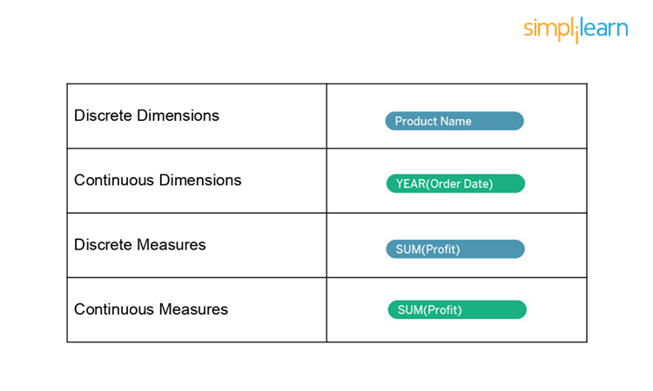

4. What Are the Filters? Name the Different Filters in Tableau.

Tableau filters are a way of restricting the content of the data that may enter a Tableau workbook, dashboard, or view.

The Different Types of Tableau Filters are:

* Extract filters
* Context filters
* Data source filters
* Filters on measures
* Filters on dimensions
* Table calculation filter

Offer Expires In

* 00 : HRS
* 46 : MIN
* 20SEC

Tableau Interview Guide

All You Need to Crack the Interview In the 1st Go[DOWNLOAD NOW](https://www.simplilearn.com/tableau-interview-questions-and-answers-article)



5. There Are Three Customer Segments in the Superstore Dataset. What Percent of the Total Profits Are Associated with the Corporate Segment?

Follow these steps:

1. Drag segment field to the rows shelf. Here, segment consists of Consumer, Corporate, and Home Office
2. Double-click on profit field under Measures.
3. Right-click on SUM (Profit) under marks card, select Quick Table Calculation, and click on Percent of the total.

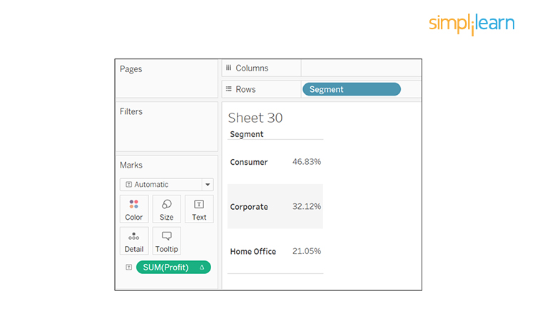

Looking above, the corporate segment has 32.12 percent of the total profits.

6. What Are the Different Joins in Tableau?

Joining is a method for combining related data on a common key. Below is a table that lists the different types of joins:

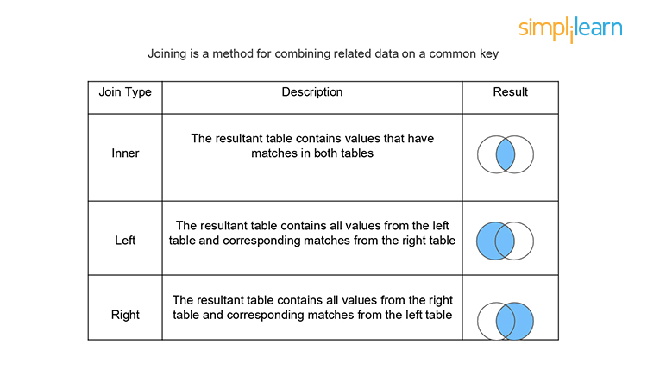

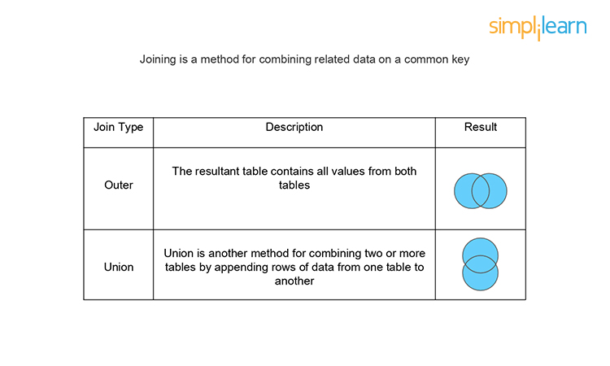

7. What is the Difference Between Joining and Blending?

Combining the data from two or more different sources is data blending, such as Oracle, Excel, and SQL Server. In data blending, each data source contains its own set of dimensions and measures.

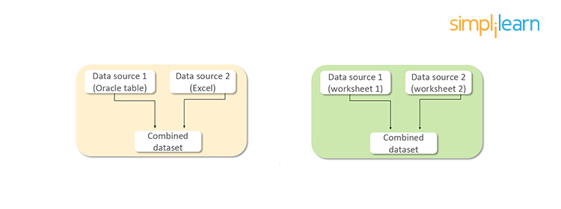

Combining the data between two or more tables or sheets within the same data source is data joining. All the combined tables or sheets contain a common set of dimensions and measures.

8. What is the Difference Between a Live Connection and an Extract?

Tableau Data Extracts are snapshots of data optimized for aggregation and loaded into system memory to be quickly recalled for visualization.

Example: Hospitals that monitor incoming patient data need to make real-time decisions.

Live connections offer the convenience of real-time updates, with any changes in the data source reflected in Tableau.

Example: Hospitals need to monitor the patient’s weekly or monthly trends that require data extracts.

Did You Know?

When you create an extract of the data, Tableau doesn't need access to the database to build the visualization, so processing is faster.

If you have a Tableau server, the extract option can be set to a refresh schedule to be updated.

9. What is a Calculated Field, and How Will You Create One?

A calculated field is used to create new (modified) fields from existing data in the data source. It can be used to create more robust visualizations and doesn’t affect the original dataset.

For example, let’s calculate the “average delay to ship.”

The data set considered here has information regarding order date and ship date for four different regions. To create a calculated field:

1. Go to Analysis and select Create Calculated Field.
2. A calculation editor pops up on the screen. Provide a name to the calculated field: Shipping Delay.
3. Enter the formula: DATEDIFF (‘day’, [Order Date], [Ship Date])
4. Click on Ok.
5. Bring Shipping Delay to the view.
6. Repeat steps 1 to 5 to create a new calculated field ‘Average Shipping Delay’ using the formula: AVG (DATEDIFF (‘day,’ [Order Date], [Ship Date]))  
     
   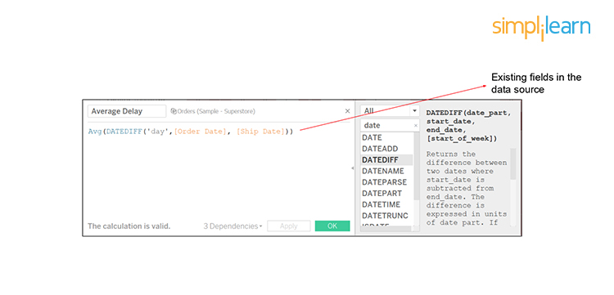
7. Drag Region field to Rows shelf and SUM(Average Shipping Delay) to the marks card; the average delay for each region gets displayed.

10. How Can You Display the Top Five and Bottom Five Sales in the Same View?

We can display it using the In/Out functionality of sets.

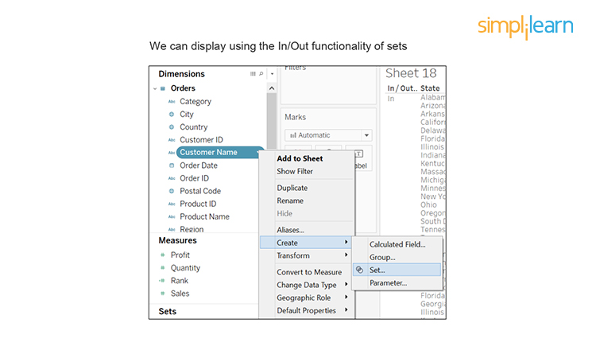

Follow these steps:

1. Drag the Customer Name field to Rows shelf and Profit field to Columns shelf to get the visualization.
2. Create a set by right-clicking on the Customer Name field. Choose to create an option and click on Set.
3. Provide the name ‘Top Customers’ to the set. Configure the set by clicking on Top tab, selecting By field, and filling the values as Top, 5, Profit, and Sum.
4. Similarly, create a second set called ‘Bottom Customers’ and fill the By Field values as Bottom, 5, Profit, and Sum.
5. Select these two sets and right-click on it. Use the option Create Combined Set. Name it ‘Top and Bottom Customers’ and include all members of both sets. Pull the Top and Bottom Customers onto Filters.

The top five and bottom five are displayed:

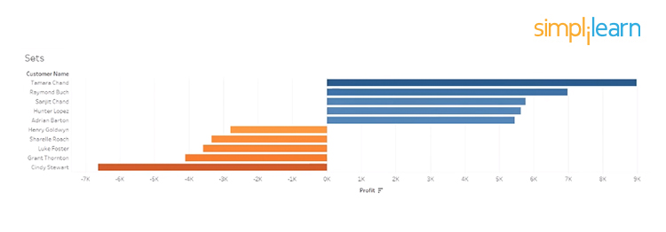

11. Is There a Difference Between Sets and Groups in Tableau?

A Tableau group is one dimensional, used to create a higher level category by using

lower-level category members. Tableau sets can have conditions and can be grouped across multiple dimensions/measures.

Example: Sub-category can be grouped by category.

Top Sales and profit can be clubbed together for different categories by creating a set:

1. Continuing with the above example of Sets, select the Bottom Customers set where customer names are arranged based on profit.
2. Go to the ‘Groups’ tab and select the top five entries from the list.
3. Right-click and select create a group option.
4. Similarly, select the bottom five entries and create their group. Hide all the other entries.

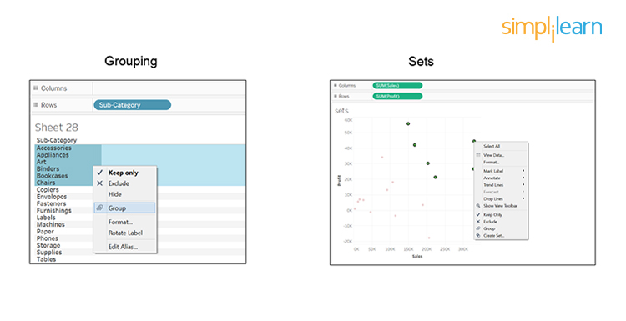

A key difference here is that the groups will consist of the same customers even if their profits change later. While for sets, if the profit changes, the top five and bottom five customers will change accordingly.

Did You Know?

We can’t use groups in calculated fields, but we can use sets.

12. What Is a Parameter in Tableau? Give an Example.

A parameter is a dynamic value that a customer could select, and you can use it to replace constant values in calculations, filters, and reference lines.

For example, when creating a filter to show the top 10 products based on total profit instead of the fixed value, you can update the filter to show the top 10, 20, or 30 products using a parameter.

Continuing with the same example of top-five and bottom five customers, follow these steps:

1. Select the drop-down arrow on the top right corner of the Data pane.
2. Click on Create Parameter and fill the details:
   1. Name - Number of top/bottom customers
   2. Select ‘Range’ for Allowable Values and fill the fields as:
      1. Minimum - 5
      2. Maximum - 20
      3. Step - 5
3. Edit the set ‘Top Customers’ by changing ‘By Field’ value of 5 with ‘Select number of top/bottom customers.’ Do the same changes in the ‘Bottom Customers’ set.
4. Go to the created parameter on the Data pane, right-click on it and select ‘Show Parameter Control.’ Now, if you increase the step within the range, the data appears as per the parameter value set.

Following is the visualization for a step size of 10:

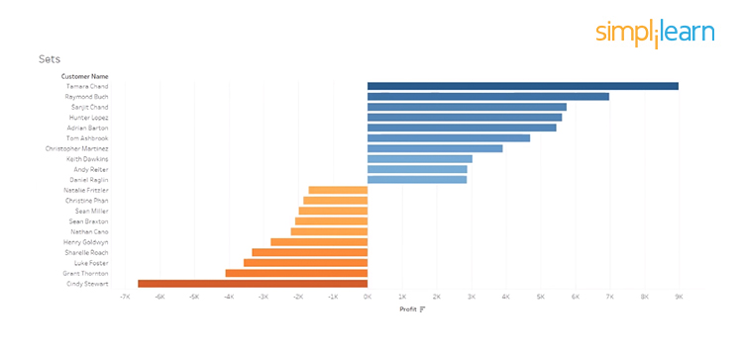

13. What is the Difference Between Treemaps and Heat Maps?

Heat Maps

A [Heat map](https://www.optimizely.com/optimization-glossary/heatmap/) is used to compare categories using color and size. In this, we can distinguish two measures.

Scenario: Show sales and profit in all regions for different product categories and sub-categories.

Follow these steps:

1. Drag Region field to Columns shelf, and Category and Sub-Category fields in Rows shelf.
2. Use the ShowMe tool and select the Heat Map.
3. Observe the hotter and colder regions in the heat map produced:

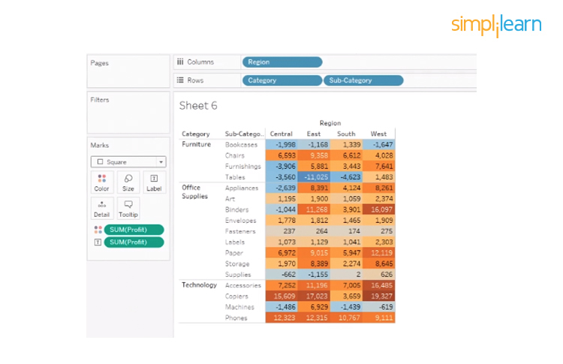

A heat map is not only defined by color, but you can also use its size. Here we define the size by sale by dragging the Sales tab to Size under marks card, comparing profit and sales through the color and size.

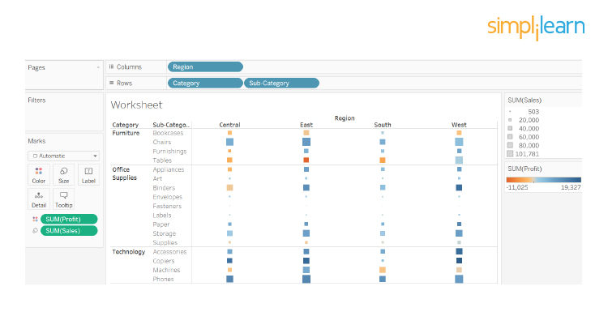

Analysis: Profit is represented by color and ranges from orange for loss to blue for profit. The total sales are represented by size.

Tree Maps

A [Tree map](http://seeingdata.org/taketime/inside-the-chart-tree-map/) is used to represent hierarchical data. The space in the view is divided into rectangles that are sized and ordered by a measure.

Scenario: Show sales and profit in all regions for different product categories and sub-categories.

1. Select two dimensions Category and Sub-Category
2. Select two measures Sales and Profit from the data pane.
3. Use the Show-me tool and select tree-map.

This is how it looks:

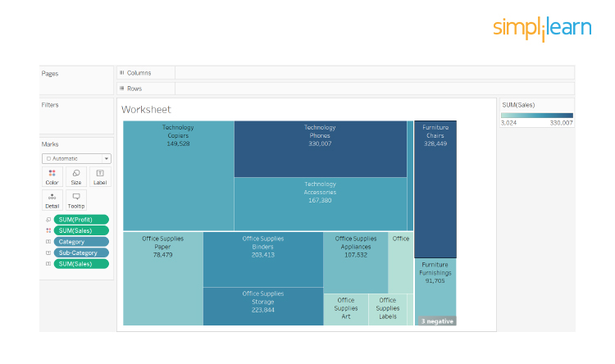

Analysis: The larger the size of the node, the higher the profit in that category. Similarly, the darker the node, the more sales in that category.

14. What is the Difference Between .twbx And .twb?

.twbx

The [.twbx](https://www.reviversoft.com/file-extensions/twbx) contains all of the necessary information to build the visualization along with the data source. This is called a packaged workbook, and it compresses the package of files altogether.

.twb

The [.twb](https://www.reviversoft.com/file-extensions/twb) contains instructions about how to interact with the data source. When it's building a visualization, Tableau will look at the data source and then build the visualization with an extract. It can’t be shared alone as it contains only instructions, and the data source needs to be attached separately.

15. Explain the Difference Between Tableau Worksheet, Dashboard, Story, and Workbook?

* Tableau uses a workbook and sheet file structure, much like Microsoft Excel.
* A workbook contains sheets, which can be a worksheet, dashboard, or a story.
* A worksheet contains a single view along with shelves, legends, and the Data pane.
* A dashboard is a collection of views from multiple worksheets.
* A story contains a sequence of worksheets or dashboards that work together to convey information.

16. What Do You Understand about the Blended Axis?

Blended Axis is used to blend two measures that share an axis when they have the same scale.

Scenario: Show Min and Max profit in the same pane and have a unified axis for both, so that it is quicker and easier to interpret the chart.

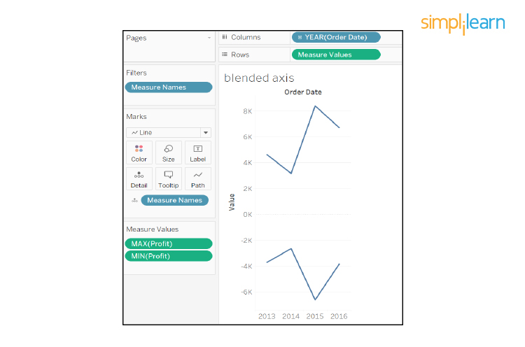

First, create a visualization that shows sales over time. Next, see profit along with sales over the same time. Here, you get two visualizations, one for sales over time and the other for-profit over time.

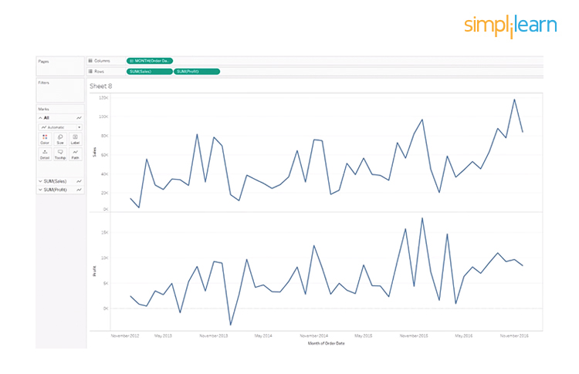

To see a visualization that has a blended axis for sales over time and profit over time, we bring in Measure Values and select the properties that we want to keep (Sales and Profit), removing all of the rest. You can now see profit and sales over one blended axis.

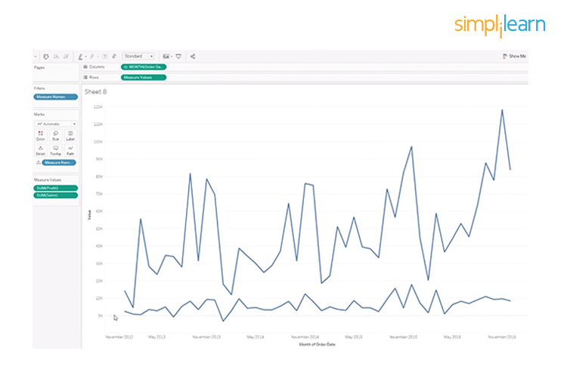

17. What is the Use of Dual-axis? How Do You Create One?

Dual Axis allows you to compare measures, and this is useful when you want to compare two measures that have different scales.

Considering the same example used in the above question, first create a visualization with sales over time and profit over time. To create a dual-axis, right-click on the second pill of the measures and select Dual Axis.

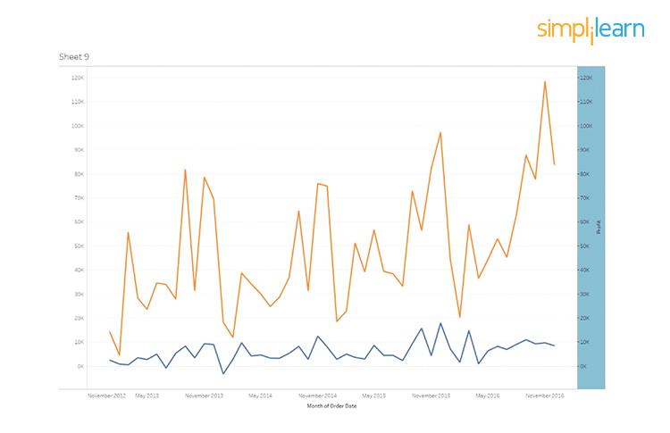

Observe that sales and profit do not share the same axis, and profit is much higher towards the end.

The difference between a blended axis and a dual-axis chart is that the blended axis uses the same scale, while a dual-axis could have two different scales and two marks cards.

Scenario: We want to show Sales by year and Profit Ratio by year in the same view.

We create a visualization of sales over time and profit ratio over time. Observe that sales and profit ratio can’t use the same scale as the profit ratio is in percentage. As we want the two parameters in the same area, we right-click on Profit Ratio and select Dual Axis.

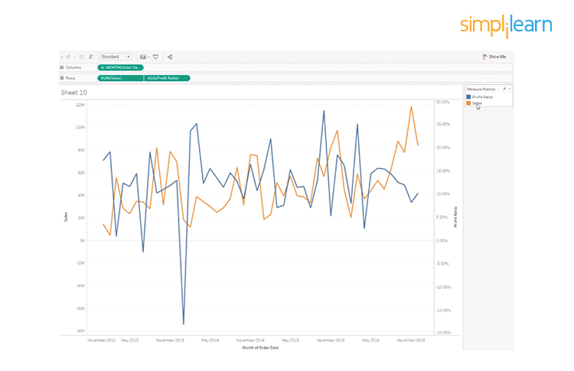

18) What Will the Following Function Return?

Left(3, “Tableau”)

Choose the correct answer:

* Tab
* Eau
* Error
* None of the above

It will return an error because the correct syntax is: left(string, num_chars). So, it should be: Left(“Tableau,” 3)

Left returns a specific number of characters from the start of the given string. If the correct syntax is followed, the result would be ‘Tab.’

19. How Do You Handle Null and Other Special Values?

If the field contains null values or if there are zeros or negative values on a logarithmic axis, Tableau cannot plot them. Tableau displays an indicator in the lower right corner of the view, and you can click the indicator and choose from the following options:

* Filter Data. Excludes the null values from the visualization using a filter. In that case, the null values are also excluded from any calculations used in the view.
* Show Data at Default Position. Shows the data at a default location on the axis.

20. Find the Top Product Subcategories by Sales Within Each Delivery Method. Which Subcategory Is Ranked #2 for First-class Ship Mode?

1. First, draw a visualization using ship mode and subcategory.
2. Next, we take sales on to the visualization as a rank table calculation.
3. Right-click on Sales and select Add Table Calculation and change the Calculation Type to Rank.
4. Select Table Down, and you get the data as shown:

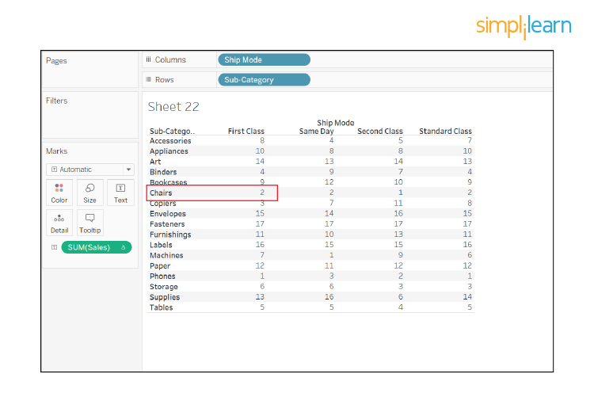

The chair is the subcategory, which is ranked #2 for the first class shipment mode.

21. Find the Customer with the Lowest Overall Profit. What is Their Profit Ratio?

Draw a visualization between Customers and their profit and sort it from smallest to biggest.

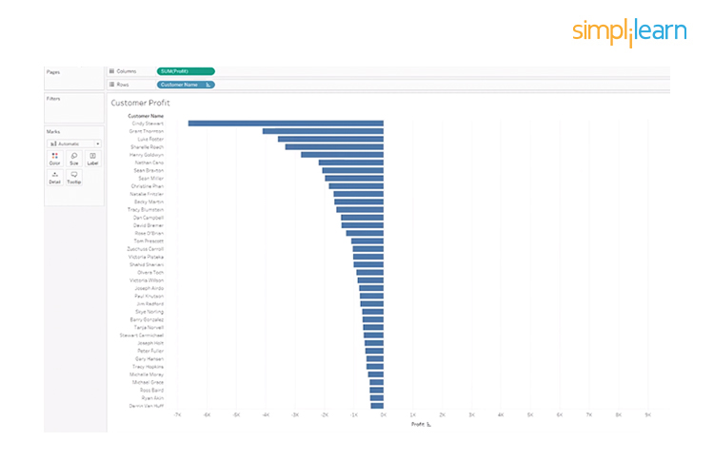

Here, Cindy Stewart is the one who has the lowest profit. To determine her profit ratio:

1. Create a calculated field named Profit Ratio.
2. Right-click on Profit Ratio under Measures and select Edit.
3. Enter the formula: SUM (PROFIT) / SUM (SALES)
4. Next, drag the Profit Ratio to the Label to find out Cindy’s profit ratio.

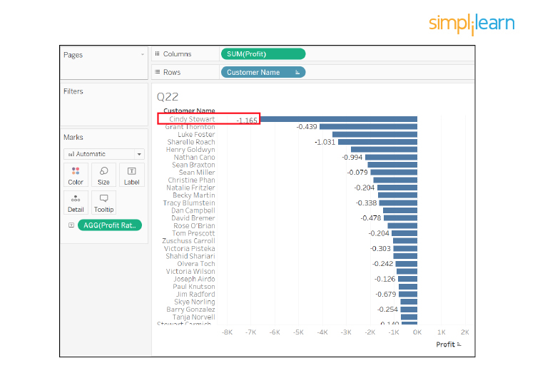

22. What is the Rank Function in Tableau?

The ranking is assigning something a position usually within a category and based on a measure. Tableau can rank in several ways like:

* rank
* rank_dense
* rank_modified
* rank_unique

Consider five stores whose sales are as shown:

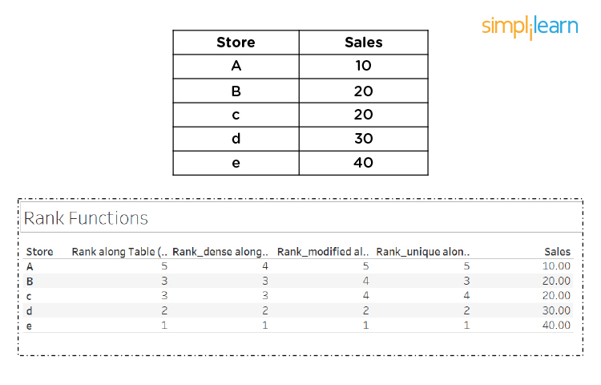

Let us understand how they are ranked based on their sales:

1. Drag Store field to Rows shelf and Sales field to the marks card.
2. Create a Calculated Field named Rank and use the formula: RANK (SUM(Sales))
3. Bring the Rank field to the marks card.
4. Double-click on the Rank field, and you can see the rank assigned to the stores based on sales.

Next, duplicate the Rank field by right-clicking on it and selecting Duplicate. Name the copy as ‘Rank Modified’ and use the formula:

RANK MODIFIED (SUM(Sales))

Bring Rank Modified to the marks card to view the data.

Repeat the same steps to create ‘Rank Dense’ and use the formula:

RANK DENSE (SUM(Sales))

Similarly, create ‘Rank Unique’ and use the formula:

RANK UNIQUE (SUM(Sales))

23. How Can You Embed a Web Page in a Dashboard?

Follow these simple steps to embed a webpage in a dashboard:

1. Go to dashboard
2. Double click ‘Webpage’ option available under ‘Objects.’
3. Enter the URL (here <https://en.wikipedia.org/wiki/>) of the webpage in the dialog box that appears

You can see the webpage appears on the dashboard.

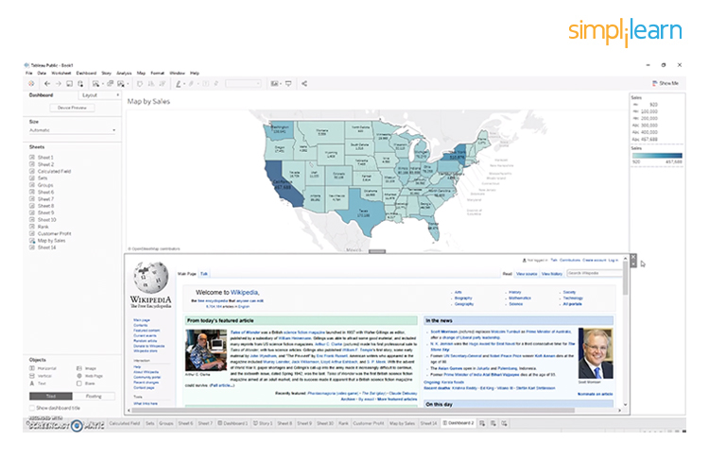

How do you make the webpage dynamic?

Begin by bringing Map by Sales into view. It shows the state's name and its sales.

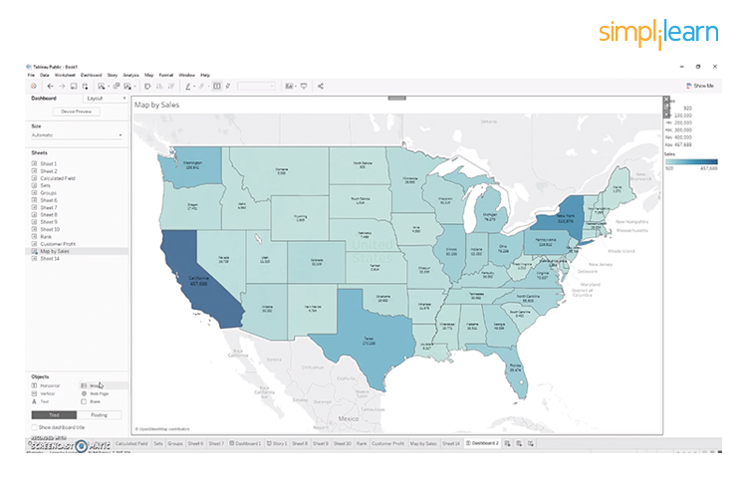

1. Go to the dashboard.
2. Double click ‘Webpage’ option available under ‘Objects.’
3. Do not provide a URL in the dialog box that appears and click on Ok.
4. Click on the Dashboard in the menu and select ‘Action.’
5. Click on ‘Add Action’ and select ‘Go to URL.’
6. Enter ‘<https://en.wikipedia.org/wiki/>’ under the URL option. Click on the arrow adjacent to it and select ‘State.’
7. Click on ‘Select option’ and hit ‘Ok.’

Now, when you click on any state like California, it brings up the California Wikipedia page. This is how to make it dynamic.

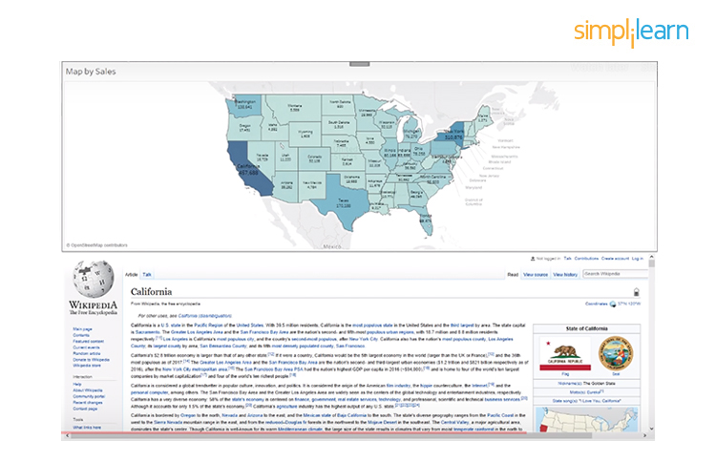

24. Design a View to Show Region Wise Profit and Sales.

Follow these simple steps to show region wise profit and sales:

1. Drag Profit and Sales field to the Rows shelf
2. Drag Region field to the Columns shelf

But for such questions, the interviewer may be looking for your mapping capabilities in Tableau.

So, you need to follow these steps to show region wise profit and sales in a better way:

1. Double click on State field to get its view
2. Go to Marks card and change the mark type from Automatic to Map.
3. Bring Region field to Color on the Marks card
4. Drag Profit, Sales, and State fields to Label on the Marks card

These steps produce a better view of region-wise profit and sales, as shown:

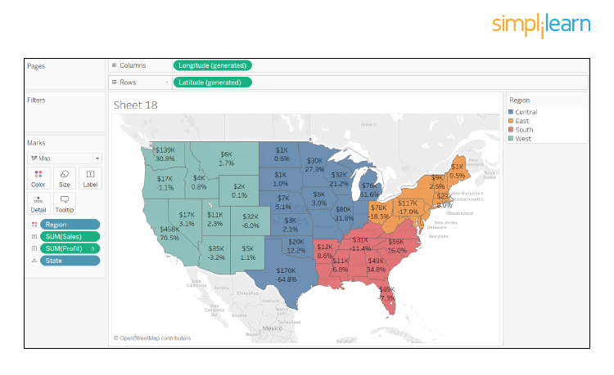

25. How Can You Optimize the Performance of a Dashboard?

There are multiple ways to optimize the performance of the dashboard like:

* Maximize the number of fields and records. You can exclude unused fields from your visualization or use extract filters.
* Limit the number of filters used, by avoiding quick filters and using action and parameter filters instead. These filters reduce query loads.
* use Min/Max instead of Average because average functions require more processing time than Min/Max
* Use boolean or numerical calculations more than string calculations. Computers can process integers and boolean much faster than strings.

Boolean > int > float > date-time > string

26. Which Visualization Will Be Used in the given Scenarios?

1. To show aggregated sales totals across a range of product categories and subcategories
2. To show the duration of events or activities
3. To show quarter wise profit growth

We would use the following visualizations for the given scenarios:

1. Treemap
2. Gantt chart
3. Waterfall chart

27. What Would You Do If Some Countries/Provinces (Any Geographical Entity) are Missing and Displaying a Null When You Use Map View?

When working with maps and geographical fields, unknown or ambiguous locations are identified by the indicator in the lower right corner of the view.

Click the indicator and choose from the following options:

* Edit Locations - correct the locations by mapping your data to known locations
* Filter Data - exclude the unknown locations from the view using a filter. The locations will not be included in calculations
* Show Data at Default Position - show the values at the default position of (0, 0) on the map.

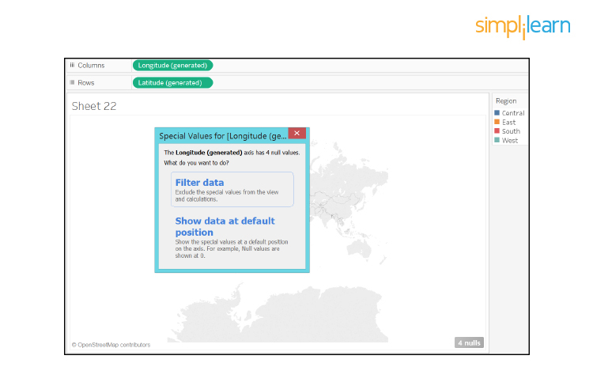

28. What is the Level of Detail (LOD) Expression?

A level of detail expression is used to run complex queries involving many dimensions at the data source level instead of bringing all the data to Tableau interface.

Consider a visualization as shown:

Here, the sales are shown for a category like Furniture and its sub-categories (Chairs, Tables, etc.). To look at sales for the furniture category as a whole and not its sub-categories, remove the sub-category from the calculation field as shown:

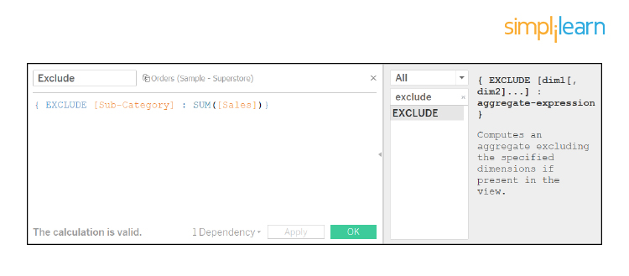

Now, the visualization looks like:

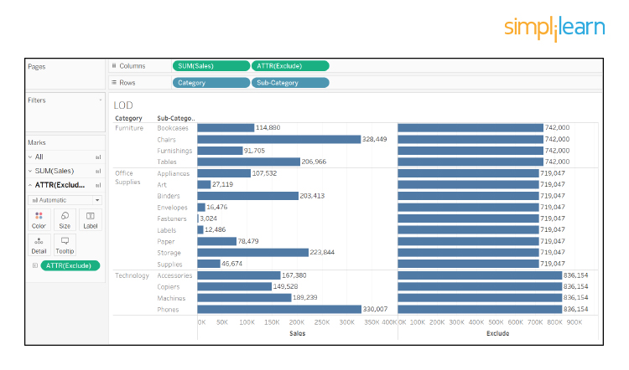

29. How Do You Calculate the Daily Profit Measures Using LOD?

LOD expressions allow us to easily create bins on aggregated data such as profit per day.

Scenario: We want to measure our success by the total profit per business day.

Create a calculated field named LOD - Profit per day and enter the formula:

FIXED [Order Date] : SUM ([Profit])

Create another calculated field named LOD - Daily Profit KPI and enter the formula:

IF [LOD - Profit per day] > 2000 then “Highly Profitable.”

ELSEIF [LOD - Profit per day] <= 0 then “Unprofitable”

ELSE “Profitable”

END

To calculate daily profit measure using LOD, follow these steps to draw the visualization:

1. Bring YEAR(Order Date) and MONTH(Order Date) to the Columns shelf
2. Drag Order Id field to Rows shelf. Right-click on it, select Measure and click on Count(Distinct)
3. Drag LOD - Daily Profit KPI to the Rows shelf
4. Bring LOD - Daily Profit KPI to marks card and change mark type from automatic to area.

The visualization is as shown:

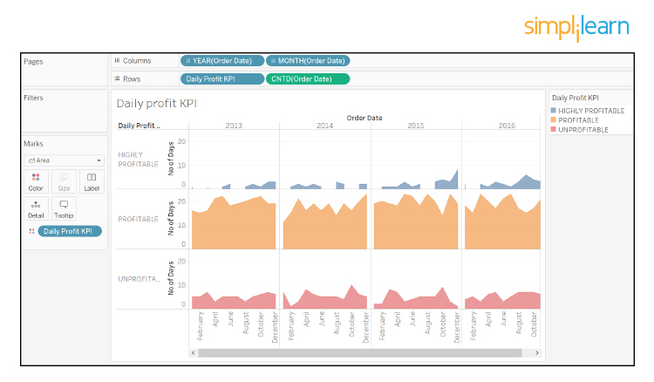

30. How Can You Schedule a Workbook in Tableau after Publishing It?

1. When you’re signed in to Tableau Server, go to Content > data sources or Content > Workbooks, depending on the type of content you want to refresh.
2. Select the checkbox for the data source or workbook you want to refresh, and then select Actions > Extract Refresh.
3. In the Refresh Extracts dialog, select Schedule a Refresh, and complete the following steps:
   1. Select the schedule you want.
   2. If available, specify whether you want a full or incremental refresh.

31. What Are the Different Types of Tableau?

The different types of Tableau are Desktop, Prep, Online, and Server.